**Bahria University,**

Karachi Campus



## LAB EXPERIMENT NO.

## 7

## LIST OF TASKS

|  |  |
| --- | --- |
| **TASK NO** | **OBJECTIVE** |
| **1** | Write a python program to implement the support vector machine on Diabetes dataset. implement the following different kernels of SVM and compare the accuracy score and visualize the confusion matrix and hyperplane. |
| **2** | Design the workflow with the help of KNIME to implement the Support Vector Machine Algorithm on any classification dataset |

**Submitted On:**

18 feb 2024

(Date: DD/MM/YY)

**TASK 1:** Write a python program to implement the support vector machine on Diabetes dataset. implement the following different kernels of SVM and compare the accuracy score and visualize the confusion matrix and hyperplane.

import pandas as pd

from sklearn.svm import SVC

from sklearn.model_selection import train_test_split

from sklearn.preprocessing import StandardScaler

from sklearn.decomposition import PCA

import matplotlib.pyplot as plt

import numpy as np

from sklearn.metrics import accuracy_score, confusion_matrix

import seaborn as sns

def plot_decision_boundary(clf, X, y, h=0.02, draw_sv=True, title="Decision Boundary"):

    x_min, x_max = X[:, 0].min() - 1, X[:, 0].max() + 1

    y_min, y_max = X[:, 1].min() - 1, X[:, 1].max() + 1

    xx, yy = np.meshgrid(np.arange(x_min, x_max, h),np.arange(y_min, y_max, h))

    plt.figure(figsize=(12, 8))

    Z = clf.predict(np.c_[xx.ravel(), yy.ravel()])

    Z = Z.reshape(xx.shape)

    plt.contourf(xx, yy, Z, alpha=0.8, cmap=plt.cm.coolwarm)

    plt.scatter(X[:, 0], X[:, 1], c=y, cmap=plt.cm.coolwarm, s=20, edgecolors='k')

    if draw_sv:

        sv = clf.support_vectors_

        plt.scatter(sv[:, 0], sv[:, 1], c='yellow', marker='x', s=100, linewidths=2, edgecolors='k')

    Z = clf.decision_function(np.c_[xx.ravel(), yy.ravel()])

    Z = Z.reshape(xx.shape)

    plt.contour(xx, yy, Z, colors='k', levels=[-1, 0, 1], alpha=0.5, linestyles=['--', '-', '--'])

    plt.title(title)

    plt.xlabel('Principal Component 1')

    plt.ylabel('Principal Component 2')

    plt.show()

file_path = 'diabetes.csv'

diabetes_data = pd.read_csv(file_path)

columns_to_fix = ['Glucose', 'BloodPressure', 'SkinThickness', 'Insulin', 'BMI']

for col in columns_to_fix:

    diabetes_data[col] = diabetes_data[col].replace(0, diabetes_data[col].median())

X = diabetes_data.drop('Outcome', axis=1)

y = diabetes_data['Outcome']

scaler = StandardScaler()

X_scaled = scaler.fit_transform(X)

pca = PCA(n_components=2)

X_pca = pca.fit_transform(X_scaled)

X_train, X_test, y_train, y_test = train_test_split(X_pca, y, test_size=0.2, random_state=42)

kernels = ['linear', 'poly', 'rbf']

models = {}

predictions = {}

accuracy_scores = {}

for kernel in kernels:

    svm_model = SVC(kernel=kernel, gamma='auto')

    svm_model.fit(X_train, y_train)

    y_pred = svm_model.predict(X_test)

    models[kernel] = svm_model

    predictions[kernel] = y_pred

    accuracy_scores[kernel] = accuracy_score(y_test, y_pred)

print("Accuracy Scores:")

print(accuracy_scores)

fig, axes = plt.subplots(1, 3, figsize=(18, 5))

fig.suptitle('Confusion Matrices for Different SVM Kernels')

for ax, kernel in zip(axes.flatten(), kernels):

    confusion_mtx = confusion_matrix(y_test, predictions[kernel])

    sns.heatmap(confusion_mtx, annot=True, fmt='d', cmap='pink', ax=ax)

    ax.set_xlabel('Predicted labels')

    ax.set_ylabel('True labels')

    ax.set_title(f'Kernel: {kernel}')

selected_kernel = 'poly'

svm_model_selected = models[selected_kernel]

plot_decision_boundary(svm_model_selected, X_pca, y, title=f"SVM Decision Boundary with {selected_kernel.capitalize()} Kernel")

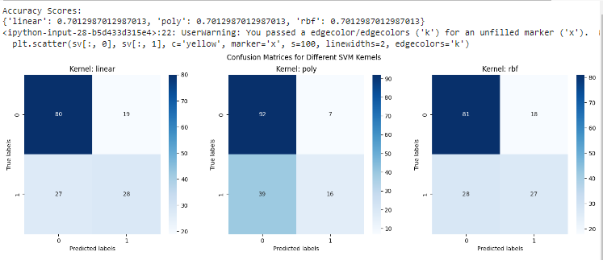

**TASK # 2:** Design the workflow with the help of KNIME to implement the Support Vector Machine Algorithm on any classification dataset



